p-ISSN: 2716-0599

e-ISSN: 2715-9604

Southeast Asian Journal of Islamic Education Management

Vol. 1 No. 1 (2020),pp 1-15

<http://sajiem.iainponorogo.ac.id/sajiem>

**The title should be simple, concise and informative**

**in sentence case format (Center, Bold, 14 pt)**

First Author (11 pt)

Affiliation, Country

*E-Mail*

Second Author (11 pt)

Affiliation, Country

*E-Mail*

|  |  |  |
| --- | --- | --- |
| DOI: https://doi.org/10.21154/sajiem.xxxxxxx | | |
| Received:00month 2019 | Revised: 00month 2019 | Approved:00month 2019 |

**Abstract(Subhead 1: Constantia, Size 11, Capitalize Each Word, Bold)**

An abstract should accompany each manuscript. It should be entirely self-consistent (i.e., with no figure, table, equation, or reference citations), not exceeding 250 words, and written as a single paragraph. Abstract using English and Indonesian. We strongly encourage authors to use the following style of structure abstracts, but without headings: (1) Background: Place the questions addressed in a broad context and highlight the purpose of the study; (2) Methods: Describe the main methods or treatments briefly applied; (3) Results: Summarize the article’s main findings; and (4) Conclusion: Indicate the main conclusion or interpretations.

**Keywords***: first keyword; second keyword; third keyword (max. five keywords)*

Introduction (Subhead 1: Constantia, Size 11, Capitalize Each Word, Bold)

The main text format consists of a flat left-right column on A4 paper (quarto). The margin text from the left and top are 2.5cm, right and bottom are 2.5 cm. The manuscript is written in Microsoft Word, single space, Constantia 11 pt., and a maximum of 18 pages.

The introduction should briefly place the study in a broad context and highlight why it is essential. It should define the purpose of the work and its significance. The current state of the research field should be reviewed carefully and key publications cited. Provide broad definitions and discussions of the topic and incorporate others’ views (literature review) into the discussion to support, refute, or demonstrate your position on the topic. Please highlight controversial and diverging hypotheses when necessary. Finally, we briefly mention the main aim of the work and highlight the principal conclusions. As far as possible, please keep the introduction comprehensible to scientists outside your particular field of research.

**Research Method (Subhead 1: Constantia, Size 11, Capitalize Each Word, Bold)**

It should be written in paragraphs. It also explains the research approach, kinds of research, data collection technique, and data analysis. They should reflect and describe the purpose of the study appropriately.

**Findings and Discussion (Subhead 1: Constantia, Size 11, Capitalize Each Word, Bold)**

It refers to the total of outcomes; the result of data analysis. The results should be discussed for each. It covers how they can be interpreted from the perspective of the theories and studies. The findings and their implications should be discussed based on the context.

The discussion interprets and describes the significance of the findings regarding what was already known research problem being investigated. It also explains any new understanding or insights emerging from the theories and/or the other research.

This section may be divided by subheadings. It should provide a concise and precise description of the experimental results, their interpretation, and the experimental conclusions are drawn. Future research directions may also be highlighted.

The findings can be presented in figures, tables, and others that make the reader understand easily. Tables and Figures are presented center, as shown in Table 1 and Figure 1.

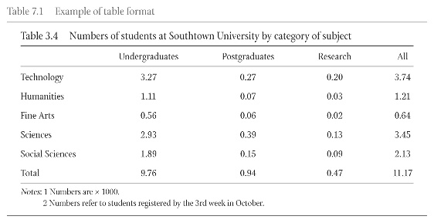Table 1. Number of Students at X University

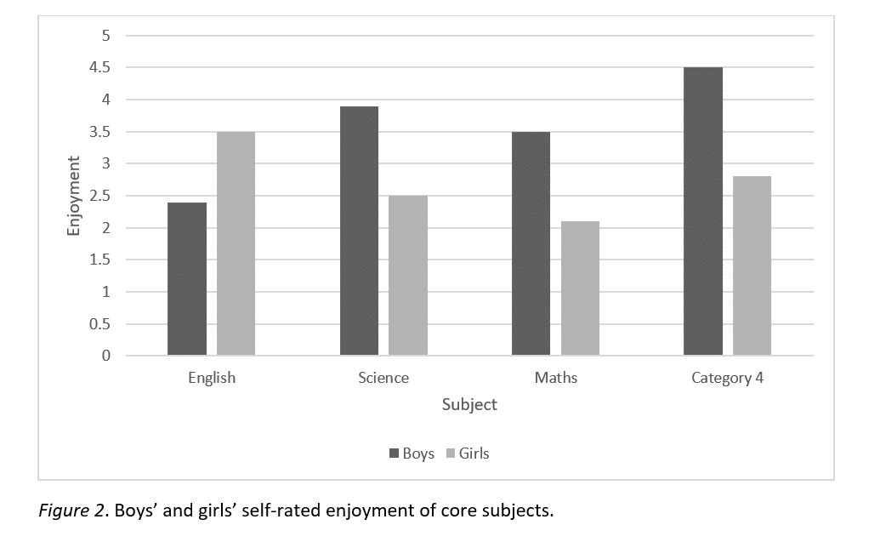

Figure 1. Boy’s and girl’s self-rated enjoyment of core subjects

Conclusion (Subhead 1: Constantia, Size 11, Capitalize Each Word, Bold)

Section title should be “Conclusion,” not “Conclusions.” Provide a discussion of the overall coverage of the article and concluding remarks.

References (Subhead 1: Constantia, Size 11, Capitalize Each Word, Bold)

References should be cited both in the text and in the references list. They should conform to the Chicago Manual of Style 16th Edition style. It should be listed in alphabetical order. Please ensure that all information in your manuscript taken from another source is substantiated with an in-text reference citation. References consist of the citations in the publication text with a minimum number of 20 references. References must be up to date. A minimum of 80% of sources published 10 years recently is required for each submission. Articles in **Sajiem: Southeast Asian Journal of Islamic Education Management** are suggested to be used as references.

Please note that your references must follow the ***Chicago Manual of Style 16th Edition style.*** The editor will return your submission for your correction if you do not correctly format your references. Author (s) may employ **Zotero, Mendeley, Endnote, etc**., as the **Reference Management**.

Axford, Barrie. *The Global System, Politics and Culture*. New York: St. Martin & rsquoss Press, 1995.

Arditi, Benjamin. “From Globalism to Globalization: The Politics of Resistance”, *New Political Science,* Volume 26, Number 1 (March 2004): 1-18.

Andreassen A., Bard. “Human Rights and Legal Empowerment of the Poor”, *Extreme Poverty and Human Rights Expert Seminar*, Geneva 23-24 February 2007, Norwegian Centre for Human rights, University of Oslo.

Geertz, Clifford. “Religion: Anthropological Study”, in David L. Sills (ed.) *International Encyclopedia of the Social Sciences*. London: Collier-Macmillan Publishers, 1965: 2-20.